Josh Holtrop
2009-11-17
Computer Science 623
Professor Tao
Grand Valley State University

In the paper “Promoting Universal Usability with Multi-Layer Interface Design,” Ben Shneiderman outlines a technique for designing user interfaces of application software to appeal to a wide variety of users and facilitate progression of users from a novice user of the application to an expert user of the application. The technique that Shneiderman proposes is “multi-layer interface design.”
The idea behind multi-layer interface design is that the interface of the application can change depending on which “layer” the user selects. On lower layers, only certain functions of the application are visible to the user (whether in menus, toolbars, help dialogs, pop-up menus, etc...). If the user switches to a higher interface layer, more functionality is exposed by the application unveiling hidden menus, ribbon toolbars, context menus, etc...
Each layer of the interface is designed to be a subset of the next higher layer. In this way, novice users can begin on the first layer of the interface and deal with only the most simple functionality at first. As they begin to master the functionality available in the first layer, they can choose to switch to a higher interface layer at any time. If the user only requires the functionality that one of the first interface layers provides, he or she can remain on that layer indefinitely and choose not to clutter the application window with additional functionality that he or she would not even use anyway.
The problem that this user interface design methodology solves is one of “universal usability.” Many users of new applications will feel overwhelmed by the plethora of functions available and visible on toolbars, ribbon menus, and context menus. The multi-layer design reduces this problem by only exposing the basic functionality at first and unveiling more as the user requests it.
Another facet of universal usability that is tackled by the multi-layer interface design methodology is users who have limited screen space or network connectivity. A lower-layer interface will often use less screen real-estate because fewer toolbar items and menus are present in the application window. This can aid users of netbooks or handheld devices, or users who must magnify the screen elements for aiding visibility.
An application that uses the network for various tasks may be able to optimize its network usage when only certain functionality is exposed to the user on certain interface layers. In this way, lower interface layers can aid in universal usability by making the application more usable to some users who would not otherwise have the resources to use the application when all of its functionality is active.
Shneiderman explains the results of a test done on users using an application built according to the multi-layer interface design methodology. He said that users who were given face time with a human explaining how the application worked responded very positively to the user interface layout and design. On the other hand, users who were given the application to begin using without much direct tutoring did not respond as favorably.
I think that in general, if effected appropriately, the multi-layer user interface design methodology is a good way to promote universal usability. However, it may not be appropriate for all types of applications. Some applications are fairly simple and have few enough functions that they can all be visible at all times and still not confuse a novice user.
More complex applications, on the other hand, can often benefit from multi-layer interface designs. One example application is xine, which is a movie player available for linux. It has a configuration screen which enables users to change various options. One of the configuration items at the top of the configuration screen is called the “Configuration experience level.” This setting controls which of multiple configuration screen layers are visible.
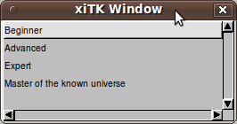

The options in xine's configuration layer selection range from “Beginner” to “Master of the known universe.” This allows users to select which layer of configuration options they would like to be able to change. Novice movie watchers will probably not care about any settings that are not visible in the “Beginner” layer, so they need not bother themselves with functionality that they do not need to alter.
Even a conceptually simple application like a calculator can benefit from multiple interface layers. For example, the standard GNOME calculator tool (gcalctool) has a “Basic” interface level which is the default interface layer. In this layer, the calculator result is visible at the top of the window, and buttons for the 10 digits, decimal point, four arithmetic functions, clearing input and backspacing, and calculating the result are the only visible buttons.
If a user wishes to utilize more functionality from the calculator application, he can switch to the “Advanced” view using the “View” ribbon menu entry at the top of the window. This interface layer adds additional buttons to the view. These additional buttons provide more arithmetic operations such as square root, squaring, inversing, and modulus. They also provide parentheses to group more complex expressions. Also, buttons for storing and recalling saved values are displayed. These are functions that many users would not require, but are available for more advanced users.
In figure 1.d of Shneiderman's paper, a “Multi-layer mushroom” diagram is depicted. In this multi-layer design, a couple of the lower interface layers sit on top of each other. Above those simple layers, however, there are different layers which expose different sets of functionality on top of the lower layers. This allows the user to select an appropriate feature set for whatever tasks he or she is attempting to perform.
The GNOME calculator tool uses this mushroom type of multi-layer design. On top of the “Basic” and “Advanced” layers, the user can select from different sets of functionality depending on the type of calculations he or she wishes to perform. There are three domain-specific layers in gcalctool: “Financial,” “Scientific,” and “Programming.” These three layers offer different new sets of calculation buttons. However, each of these layers includes the same set of buttons that are in the “Advanced” view, which is a superset of the “Basic” view.
This “multi-layer mushroom” design is appropriate for such a calculator tool because calculator users calculating financial data are often interested in interest rate calculations from the “Financial” view layer, but not centimeter-to-inch conversion factors or binary representations from the other views. Similarly, programmer users are very likely to make use of bitwise operators available in the “Programming” view but not the functions available in the other views.
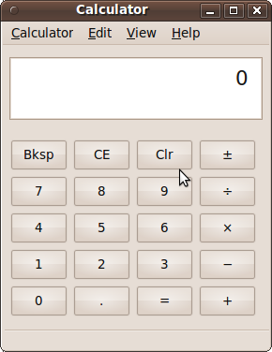
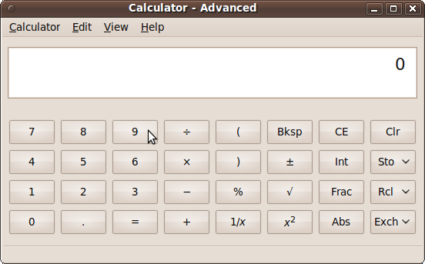

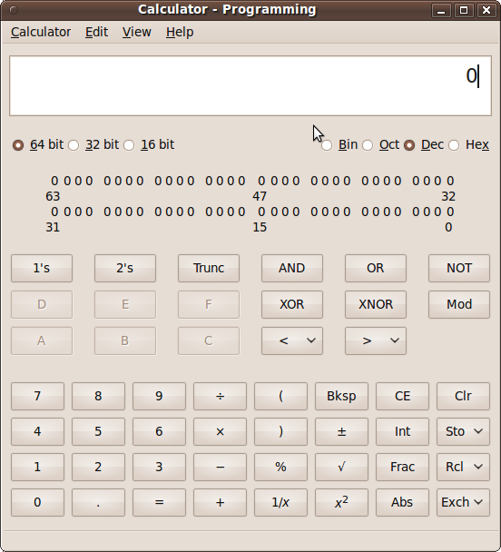

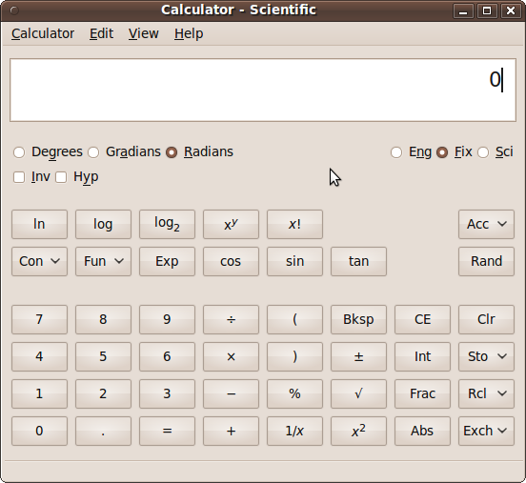

Figure 1. Various GNOME calculator interface layers

One user profile of the GNOME calculator tool would be a basic user who just wants to perform arithmetic calculations using the regular four arithmetic operators instead of using a physical four-function desktop calculator. For such a user, the “Basic” interface level is definitely sufficient. The user can launch the tool and, as Shneiderman describes, become an “expert” of the current interface level. For such a basic user, there is really no reason why the user should increase the interface layer level at all.
Another user profile is a C programmer who uses the GNOME calculator both to perform common arithmetic calculations but also to use the results when developing programs. Such a user may often wish to see the binary or hexadecimal representations of a calculated result, or to input operands in a base other than decimal.
This user would likely switch to the “Programming” view from the View menu when launching gcalctool for the first time. The application then remembers the selected interface layer so that the user does not need to re-select it upon launching the application a subsequent time. Once in “Programming” mode, the user would click on “Bin”, “Oct”, “Dec”, or “Hex” to switch which base to work in. The results are also visible in binary representation above the “Programming”-specific buttons in the application window.
One example task that a programmer user of gcalctool may do is to find the decimal value of the hexadecimal equation “(FF – 10) >> 2”. An example HTA is provided for how a user may accomplish this task (see next page).
One potential issue with Shneiderman's multi-layer interface design principle is that progressing from one layer to another should not make it more difficult to carry out a task that one knew how to carry out at a lower layer. For example, moving to a higher interface layer should not drastically reposition tools, change menu item text, or change keyboard shortcuts. This would confuse and annoy users.
For example, in Shneiderman's conclusion, he mentions “Even expert users might appreciate lower layers since frequent operations might be accomplished with fewer steps. ” It should not be the case that users can do the same operation with fewer steps at a lower interface level. If this is the case, that means that the function was somehow moved or repositioned to be less accessible in a higher layer than in the lower one. This has the potential to annoy users and make them not want to use the system.
For the most part, the multi-layer user interface design paradigm has the potential to increase universal usability and user acceptance of the application software being used. If the application is simple enough it may not benefit from multiple interface levels. If it is complex enough to warrant multiple layers, however, the presence of the layers may be beneficial to the user if they are designed properly. Careful attention should be placed into the mechanism used to actually switch interface layers. Also, the functions available in each separate layer should be thought out thoroughly. Following these guidelines should lead to higher acceptance of multi-layer interfaces across a broad range of applications.



